EDA USING POWER BI

WEEK – 1

REPORT

SUBMITTED BY
Divya Dharshni P
E25DA014

Week 1:
Superstore Sales Data Import, Power Query & Data Cleaning
Dataset:
Superstore Sales Dataset
Problem Statement:
A retail organization wants to analyze its sales data to understand customer purchases, product categories, regional performance, and profitability. Before creating a business intelligence dashboard, the raw Superstore dataset must be imported, cleaned, transformed, and prepared in Power BI.
Objectives:
Import data into Power BI Desktop and navigate Report, Data, and Model views.
Inspect dataset attributes using Power Query Editor; verify data types, missing values, and record uniqueness.
Perform column transformations (rename, split, text trimming, data type coercion).
Extract temporal attributes from Order Date (Year, Quarter, Month, Day, Day of Week).

Tasks & Deliverables:
1.Load Superstore CSV into Power Query Editor.
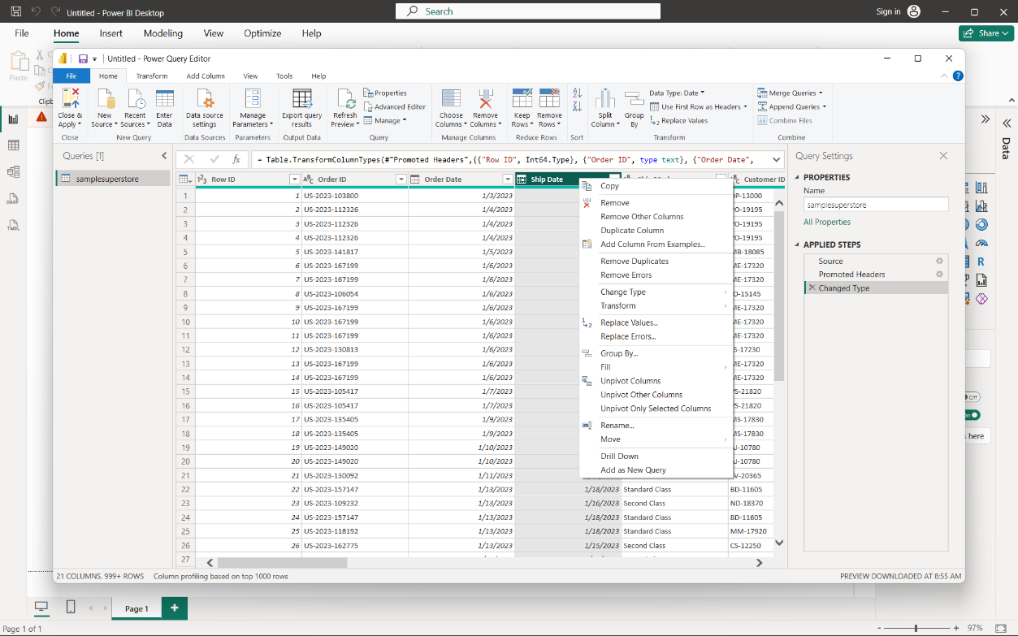

2.Standardize text formatting across categorical attributes (Category, Sub-Category, Segment). 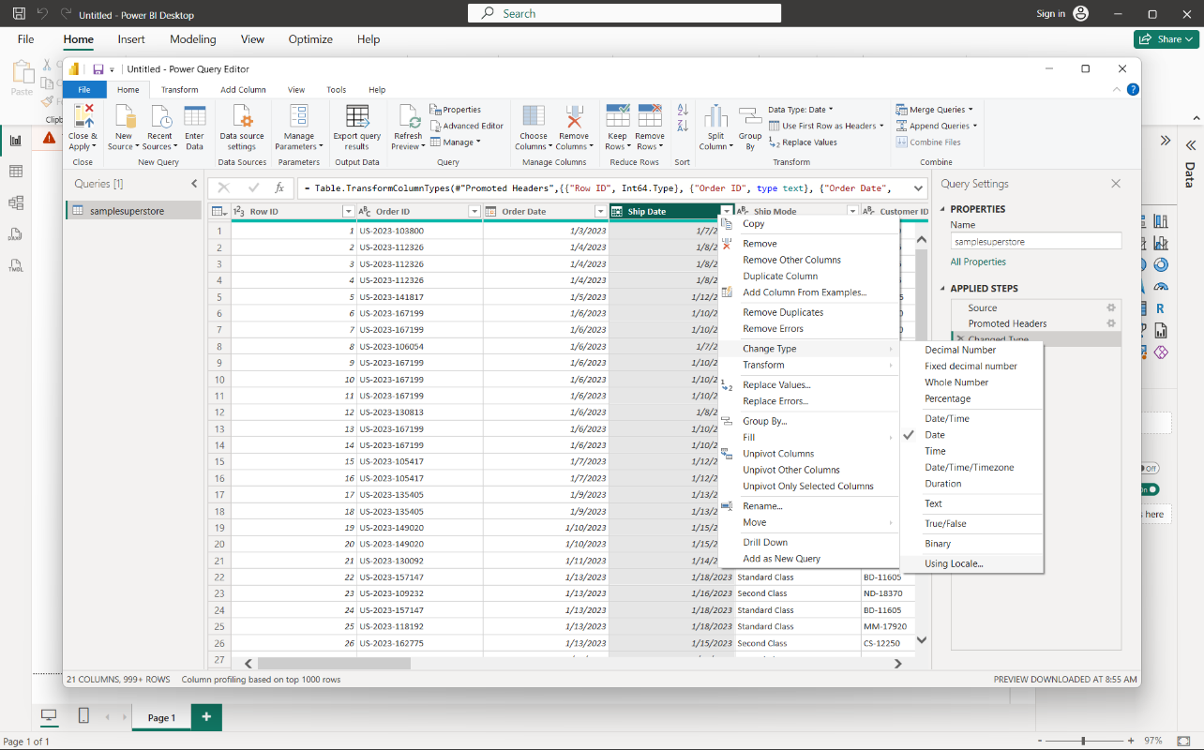

3.Perform column transformations (rename, split, text trimming, data type coercion).

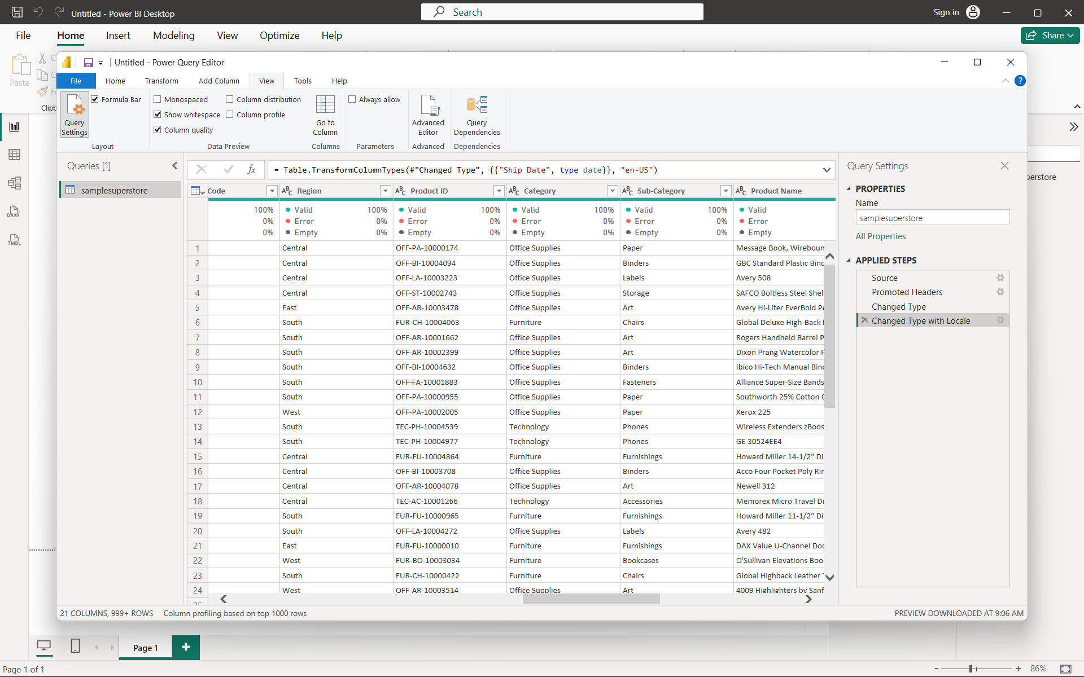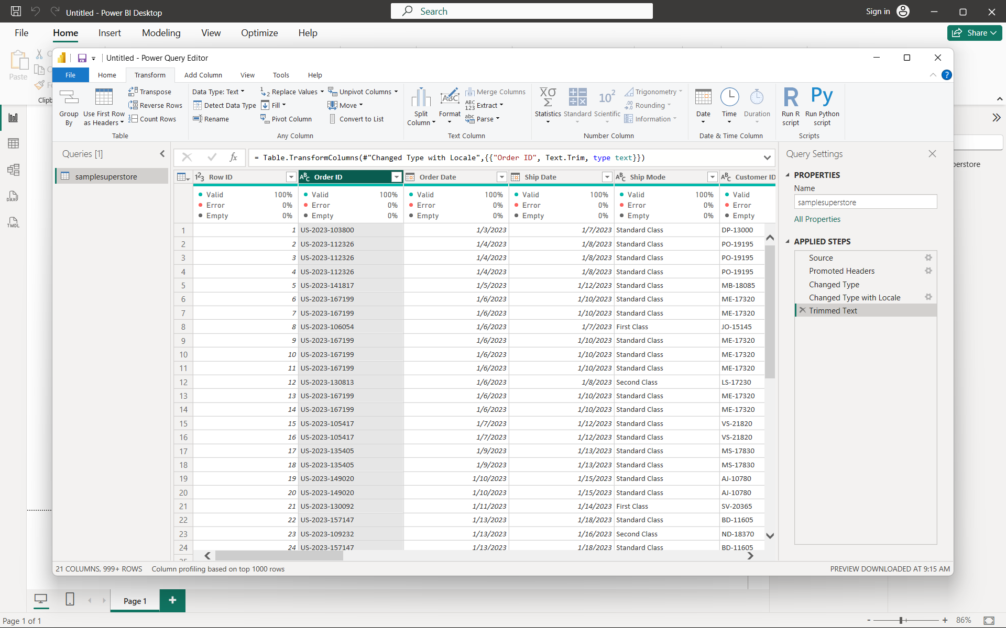

4. Extract temporal attributes from Order Date (Year, Quarter, Month, Day, Day of Week).”
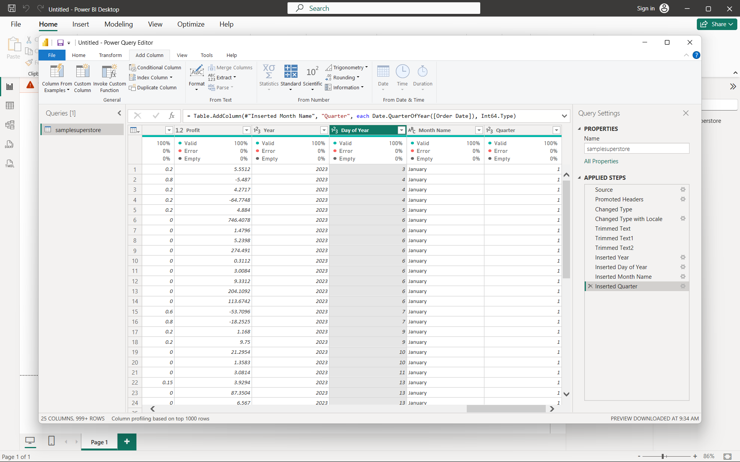

5. Close & Apply transformations to load a clean data model
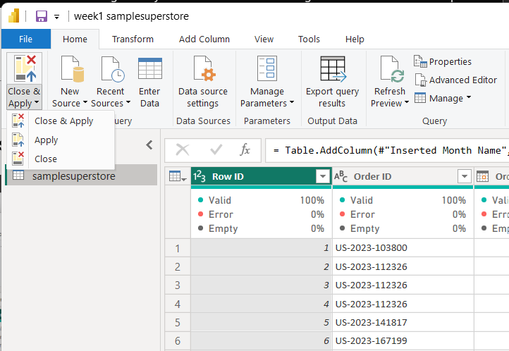

Conclusion:
The Superstore Sales dataset was successfully imported and cleaned using Power Query in Power BI. The data types were verified, unnecessary inconsistencies were handled, and required column transformations were performed. Date-related attributes were also extracted from the Order Date column. The cleaned dataset is now ready for further analysis and visualization in Power BI.

